AP Precalculus FRQ #3 Practice
- You are welcome to edit, print, or post the contents of this document to your heart’s content. Teachers, you can include these problems on classwork, homework, assessments, optional extra practice, or wherever else they may be helpful. However, I ask that you do not remove my name from the footer. Instead, just add your own name to take credit for any improvements you make (e.g. “Written by QED-Math, edited by Mr. Foresee” or “Written by QED-Math, perfected by Mrs. Simpson”).
- Note that the graph given in FRQ 3 part A on the AP exam will have points F and P corresponding with maxima, point J corresponding with a minimum, and points G and K on the midline. The graph given in the first problem in this document (Ferris Wheel labeled “Antelope”) is a direct copy of how this graph will appear in the AP Precalculus Free Response Booklet. However, I have made the didactic choice to in this document include variety in how these graphs appear (compare Antelope/Ferris Wheel to Baboon/Spit Roast).
- Some of the scenarios presented in these problems have been animated online. Truthfully, I have not found a great use for this. But I share it in case it is helpful.

In case it is helpful, the following summarizes each problem in this document.
Problem | Sin/Cos | Given h Info |  |  |  | Graph | Given $t$ Point(s) | Part C Points | C(i) Answer
Problem | Sin/Cos | Maximum | Midline | Minimum | Amplitude
Antelope | Cos |  | X |  | X | Traditional | G – mid | J/K | A
Baboon | Cos |  | X | X |  | Nontraditional | K – min | F/G | A
Caterpillar | Cos | X |  | X |  | Traditional | J – min | G/J | D
Dingo | Sin | X |  | X |  | Traditional | F/P – max | G/J | B
Elephant | Sin |  |  | X | X | Nontraditional | F – mid | G/J | B
Flamingo | Sin |  | X |  | X | Traditional | F/P – max | F/G | B
Giraffe | Sin | X |  | X |  | Traditional | J – min | K/P | A
Hippopotamus | Cos | X |  | X |  | Nontraditional | G – max | K/P | A
Iguana | Cos |  | X |  | X | Traditional | G – mid | G/J | B
Jaguar | Sin | X | X | X |  | Traditional | G – mid | J/K | C
Koala | Cos | (sort of) |  | X | (sort of) | Nontraditional | K – min | K/P | A
Leporidae | Sin | X |  | X |  | Traditional | F/P – max | G/J | B

FRQ 3 Practice – Antelope
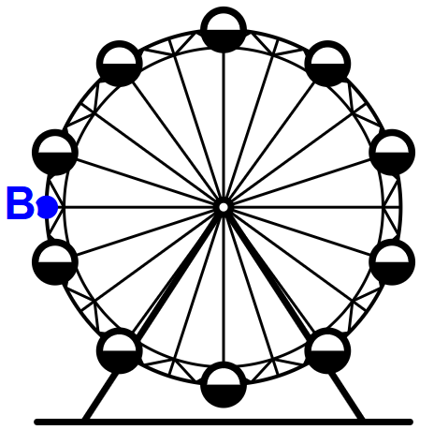
Counterclockwise
Note: Figure not drawn to scale.
The London Eye Ferris Wheel rotates in a counterclockwise direction and completes one revolution in twenty-eight minutes. Point $B$ is on the edge of the Ferris wheel and is located directly to the left of the center of the Ferris wheel at time $t=0$, as indicated in the figure. Point B is $62$ meters from the center of the Ferris wheel. The center of the London Eye is $75$ meters off the ground. As the London Eye rotates at a constant speed, the distance between $B$ and the ground periodically decreases and increases.
The sinusoidal function $h$ models the distance between $B$ and the ground, in meters, as a function of time $t$ in minutes.
- The graph of $h$ and its dashed midline for two full cycles is shown. Five points, $F$, $G$, $J$, $K$, and $P$ are labeled on the graph. No scale is indicated, and no axes are presented.
Determine possible coordinates $\left(t, h\left(t\right)\right)$ for the five points: $F, G, J, K,$ and $P$.
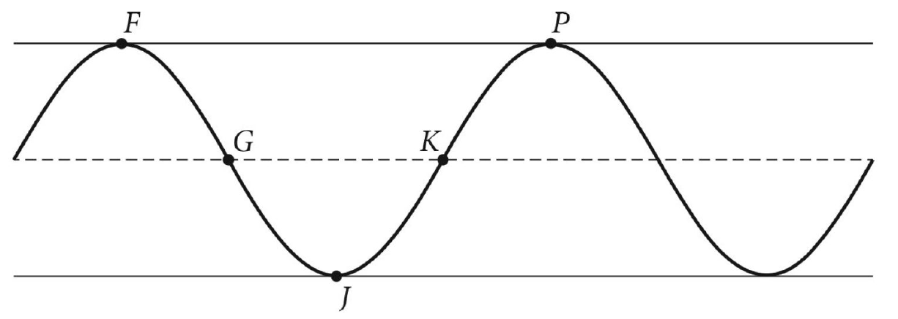
- The function $h$ can be written in the form $h\left(t\right)=a\cos\left(b\left(t+c\right)\right)+d$. Find values of constants $a, b, c,$ and $d$.
- Refer to the graph of $h$ in part (A). The $t$-coordinate of $J$ is $t_{1}$ and the $t$-coordinate of $K$ is $t_{2}$.
- On the interval $\left(t_{1},t_{2}\right)$, which of the following is true about $h$?
  - $h$ is positive and increasing
  - $h$ is positive and decreasing
  - $h$ is negative and increasing
  - $h$ is negative and decreasing
- On the interval $\left(t_{1}, t_{2}\right)$, describe the concavity of the graph of $h$ and determine whether the rate of change of $h$ is increasing or decreasing.

FRQ 3 Practice – Baboon
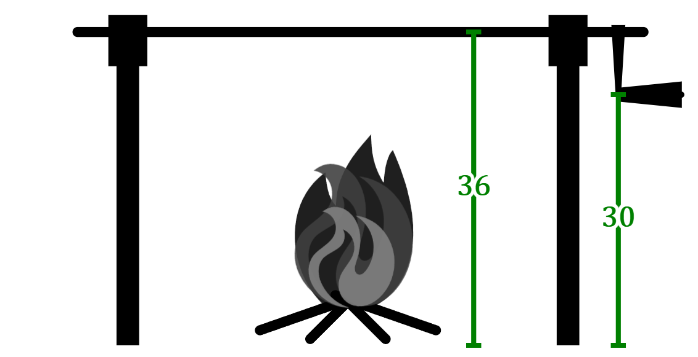
Note: Figure not drawn to scale.
A roasting spit is used to slowly turn food over a fire, letting it roast evenly. The spit is $36$ inches off the ground, as is shown in the diagram. As the handle is cranked, the roasting spit turns and the height of the handle periodically increases and decreases. At time $t=0$, the handle is $30$ inches from the ground, the lowest height it ever reaches. The handle turns at a steady rate and makes $6$ complete turns every thirty minutes.
The sinusoidal function $h$ models the distance between the handle and the ground, in inches, as a function of time $t$ in minutes.
- The graph of $h$ and its dashed midline for two full cycles is shown. Five points, $F$, $G$, $J$, $K$, and $P$ are labeled on the graph. No scale is indicated, and no axes are presented.
Determine possible coordinates $\left(t, h\left(t\right)\right)$ for the five points: $F, G, J, K,$ and $P$.
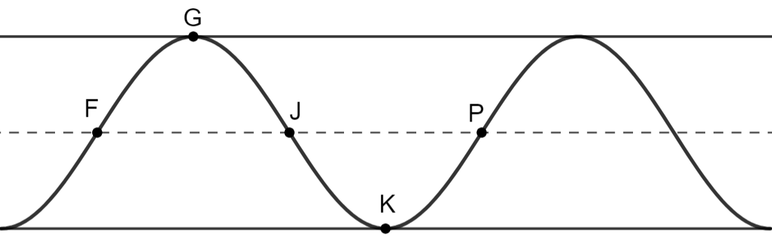
- The function $h$ can be written in the form $h\left(t\right)=a\cos\left(b\left(t+c\right)\right)+d$. Find values of constants $a, b, c,$ and $d$.
- Refer to the graph of $h$ in part (A). The $t$-coordinate of $F$ is $t_{1}$ and the $t$-coordinate of $G$ is $t_{2}$.
- On the interval $\left(t_{1},t_{2}\right)$, which of the following is true about $h$?
  - $h$ is positive and increasing
  - $h$ is positive and decreasing
  - $h$ is negative and increasing
  - $h$ is negative and decreasing
- On the interval $\left(t_{1}, t_{2}\right)$, describe the concavity of the graph of $h$ and determine whether the rate of change of $h$ is increasing or decreasing.

FRQ 3 Practice – Caterpillar
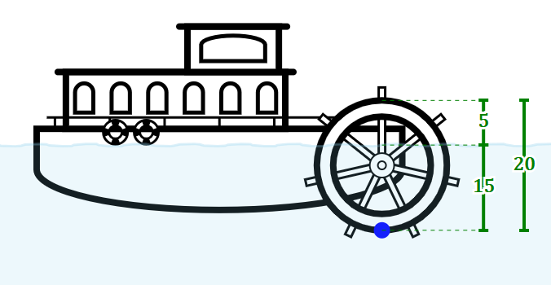
Note: Figure not drawn to scale. Also not realistic. This is some Mickey Mouse nonsense.
On a paddle steamer ship, steam turns a circular paddle that propels the ship forward in water. On the PS Waverly, the paddle is a circle with diameter $20$ feet. The highest a point on the paddle reaches as it turns is a height of $5 \text{ft}$ above the water. The lowest a point on the paddle reaches is a height of $15 \text{ft}$ below the water. Let this be considered a height of $-15 \text{ft}$. The paddle turns at a constant rate, making one complete revolution every $4$ seconds. At time $t=0$, a certain point on the paddle is at the bottom of its rotation at a height of $-15 \text{ft}$.
The sinusoidal function $h$ models the height of this point above the water, in feet, as a function of time $t$ in seconds. $h$ uses the convention that distance below the water is considered negative height.
- The graph of $h$ and its dashed midline for two full cycles is shown. Five points, $F$, $G$, $J$, $K$, and $P$ are labeled on the graph. No scale is indicated, and no axes are presented.
Determine possible coordinates $\left(t, h\left(t\right)\right)$ for the five points: $F, G, J, K,$ and $P$.
- The function $h$ can be written in the form $h\left(t\right)=a\cos\left(b\left(t+c\right)\right)+d$. Find values of constants $a, b, c,$ and $d$.
- Refer to the graph of $h$ in part (A). The $t$-coordinate of $G$ is $t_{1}$ and the $t$-coordinate of $J$ is $t_{2}$.
- On the interval $\left(t_{1},t_{2}\right)$, which of the following is true about $h$?
  - $h$ is positive and increasing
  - $h$ is positive and decreasing
  - $h$ is negative and increasing
  - $h$ is negative and decreasing
- On the interval $\left(t_{1}, t_{2}\right)$, describe the concavity of the graph of $h$ and determine whether the rate of change of $h$ is increasing or decreasing.

FRQ 3 Practice – Dingo
In Fairbanks, Alaska, days in the summer tend to have many more hours of sunlight than days in the winter. In general, the winter solstice in late December tends to have only four hours of sunlight, the shortest length of sunlight Fairbanks gets all year. Six months later, Fairbanks may get twenty-two hours of sunlight in late June during the summer solstice, the day marked by the most sunlight. From the winter solstice to the summer solstice, the amount of sunlight increases. From the summer solstice to the next winter solstice, the amount of sunlight decreases.
The sinusoidal function $h$ models the amount of sunlight, in hours, Fairbanks gets in a day as a function of time $t$ in months since the summer solstice.
- The graph of $h$ and its dashed midline for two full cycles is shown. Five points, $F$, $G$, $J$, $K$, and $P$ are labeled on the graph. No scale is indicated, and no axes are presented.
Determine possible coordinates $\left(t, h\left(t\right)\right)$ for the five points: $F, G, J, K,$ and $P$.
- The function $h$ can be written in the form $h\left(t\right)=a\sin\left(b\left(t+c\right)\right)+d$. Find values of constants $a, b, c,$ and $d$.
- Refer to the graph of $h$ in part (A). The $t$-coordinate of $G$ is $t_{1}$ and the $t$-coordinate of $J$ is $t_{2}$.
- On the interval $\left(t_{1},t_{2}\right)$, which of the following is true about $h$?
  - $h$ is positive and increasing
  - $h$ is positive and decreasing
  - $h$ is negative and increasing
  - $h$ is negative and decreasing
- On the interval $\left(t_{1}, t_{2}\right)$, describe the concavity of the graph of $h$ and determine whether the rate of change of $h$ is increasing or decreasing.

FRQ 3 Practice – Elephant
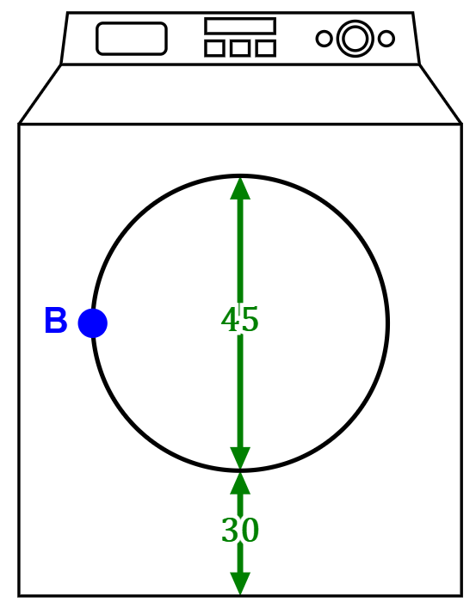
Note: Figure not drawn to scale.
Front-loading washing machines spin clothes using a cylindrical drum. On a certain washing machine, the drum has diameter $45 \text{cm}$. Point B is a specific point on the edge of the drum. During the machine’s spin cycle, Point B makes $1200$ revolutions every $60$ seconds, spinning at a steady rate in the clockwise direction. The closest to the ground point B ever reaches is $30$ cm above the ground. Let time $t=0$ refer to a time at which point $B$ is directly to the left of the center of rotation, as shown in the diagram.
The sinusoidal function $h$ models the distance between $B$ and the ground, in centimeters, as a function of time $t$ in seconds.
- The graph of $h$ and its dashed midline for two full cycles is shown. Five points, $F$, $G$, $J$, $K$, and $P$ are labeled on the graph. No scale is indicated, and no axes are presented.
Determine possible coordinates $\left(t, h\left(t\right)\right)$ for the five points: $F, G, J, K,$ and $P$.
- The function $h$ can be written in the form $h\left(t\right)=a\sin\left(b\left(t+c\right)\right)+d$. Find values of constants $a, b, c,$ and $d$.
- Refer to the graph of $h$ in part (A). The $t$-coordinate of $G$ is $t_{1}$ and the $t$-coordinate of $J$ is $t_{2}$.
- On the interval $\left(t_{1},t_{2}\right)$, which of the following is true about $h$?
  - $h$ is positive and increasing
  - $h$ is positive and decreasing
  - $h$ is negative and increasing
  - $h$ is negative and decreasing
- On the interval $\left(t_{1}, t_{2}\right)$, describe the concavity of the graph of $h$ and determine whether the rate of change of $h$ is increasing or decreasing.

FRQ 3 Practice – Flamingo
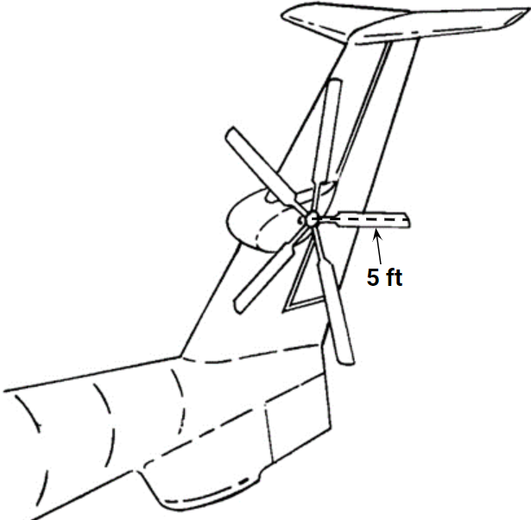
Note: Figure not drawn to scale.
The tail rotor on a Sikorsky S-72 RSRA helicopter consists of five blades, and each blade is $5$ feet long. During maintenance, the rotor is spun at a constant rate of $5$ rotations per minute, and the center of the rotor is $12 \text{ft}$ above the ground. At time $t=0$, a point on the tip of one of the rotor’s blades is at its maximum height.
The sinusoidal function $h$ models the distance between that point and the ground, in feet, during maintenance as a function of time $t$ in seconds.
- The graph of $h$ and its dashed midline for two full cycles is shown. Five points, $F$, $G$, $J$, $K$, and $P$ are labeled on the graph. No scale is indicated, and no axes are presented.
Determine possible coordinates $\left(t, h\left(t\right)\right)$ for the five points: $F, G, J, K,$ and $P$.
- The function $h$ can be written in the form $h\left(t\right)=a\sin\left(b\left(t+c\right)\right)+d$. Find values of constants $a, b, c,$ and $d$.
- Refer to the graph of $h$ in part (A). The $t$-coordinate of $F$ is $t_{1}$ and the $t$-coordinate of $G$ is $t_{2}$.
- On the interval $\left(t_{1},t_{2}\right)$, which of the following is true about $h$?
  - $h$ is positive and increasing
  - $h$ is positive and decreasing
  - $h$ is negative and increasing
  - $h$ is negative and decreasing
- On the interval $\left(t_{1}, t_{2}\right)$, describe the concavity of the graph of $h$ and determine whether the rate of change of $h$ is increasing or decreasing.
FRQ 3 Practice – Giraffe
As a human runs, the height of the head increases and decreases periodically. For a certain person’s gait pattern, the maximum height of his head is $178 \text{cm}$ and the minimum value of the height of his head is $170 \text{cm}$. This person takes $3$ complete strides per second as he runs. At time $t=0$, his height is at a minimum.
The sinusoidal function $h$ models the height of this person’s head, in centimeters, as a function of time $t$ in seconds.
- The graph of $h$ and its dashed midline for two full cycles is shown. Five points, $F$, $G$, $J$, $K$, and $P$ are labeled on the graph. No scale is indicated, and no axes are presented.
Determine possible coordinates $\left(t, h\left(t\right)\right)$ for the five points: $F, G, J, K,$ and $P$.
- The function $h$ can be written in the form $h\left(t\right)=a\sin\left(b\left(t+c\right)\right)+d$. Find values of constants $a, b, c,$ and $d$.
- Refer to the graph of $h$ in part (A). The $t$-coordinate of $K$ is $t_{1}$ and the $t$-coordinate of $P$ is $t_{2}$.
- On the interval $\left(t_{1},t_{2}\right)$, which of the following is true about $h$?
  - $h$ is positive and increasing
  - $h$ is positive and decreasing
  - $h$ is negative and increasing
  - $h$ is negative and decreasing
- On the interval $\left(t_{1}, t_{2}\right)$, describe the concavity of the graph of $h$ and determine whether the rate of change of $h$ is increasing or decreasing.

FRQ 3 Practice – Hippopotamus
The human heart pumps blood around the body. It accomplishes this by periodically contracting and relaxing. At full volume, Christiaan’s heart contains $180 \text{mL}$. After pushing blood out, Christiaan’s heart contains $80 \text{mL}$ of blood, the lowest volume it ever contains. Christiaan’s heart beats $50$ times per minute, meaning that $50$ times each minute, Christiaan goes through the cycle of having his heart full, then roughly half full, then back to full again.
The sinusoidal function $h$ models the volume of Christiaan’s heart, in milliliters, as a function of time $t$ in minutes. Let $t=0$ refer to a point at which Christiaan’s heart is at full volume.
- The graph of $h$ and its dashed midline for two full cycles is shown. Five points, $F$, $G$, $J$, $K$, and $P$ are labeled on the graph. No scale is indicated, and no axes are presented.
Determine possible coordinates $\left(t, h\left(t\right)\right)$ for the five points: $F, G, J, K,$ and $P$.
- The function $h$ can be written in the form $h\left(t\right)=a\cos\left(b\left(t+c\right)\right)+d$. Find values of constants $a, b, c,$ and $d$.
- Refer to the graph of $h$ in part (A). The $t$-coordinate of $K$ is $t_{1}$ and the $t$-coordinate of $P$ is $t_{2}$.
- On the interval $\left(t_{1},t_{2}\right)$, which of the following is true about $h$?
  - $h$ is positive and increasing
  - $h$ is positive and decreasing
  - $h$ is negative and increasing
  - $h$ is negative and decreasing
- On the interval $\left(t_{1}, t_{2}\right)$, describe the concavity of the graph of $h$ and determine whether the rate of change of $h$ is increasing or decreasing.

FRQ 3 Practice – Iguana
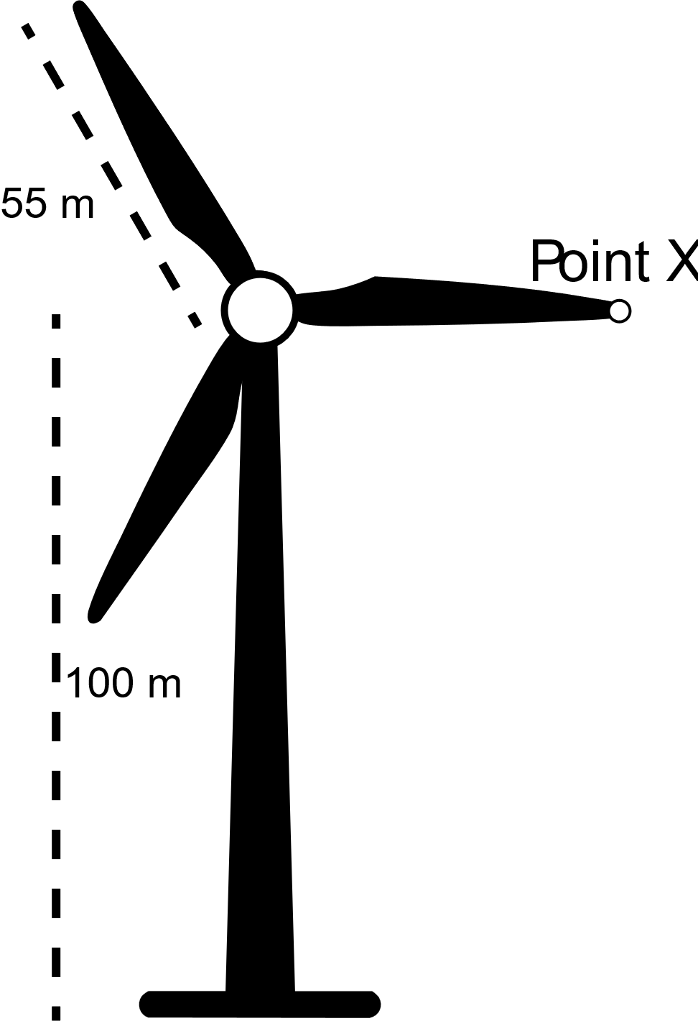
Note: Figure not drawn to scale.
The figure shows a wind turbine with the tip of one blade of the turbine labeled “Point $X$”. At time $t=1$, Point $X$ is located $100 \text{m}$ above the ground, directly to the right of the center of the head of the turbine. At this time, the height of Point $X$ is decreasing as the turbine turns clockwise at a steady rate. Point $X$ is always $55 \text{m}$ from the center of the head of the turbine as this is the length of each blade. As time goes on, the head of the turbine rotates and the height of Point $X$ rises and falls, making exactly 10 revolutions every $60$ seconds.
The sinusoidal function $h$ models the height of Point $X$ above the ground, in meters, as a function of time $t$ in seconds.
- The graph of $h$ and its dashed midline for two full cycles is shown. Five points, $F$, $G$, $J$, $K$, and $P$ are labeled on the graph. No scale is indicated, and no axes are presented.
Determine possible coordinates $\left(t, h\left(t\right)\right)$ for the five points: $F, G, J, K,$ and $P$.
- The function $h$ can be written in the form $h\left(t\right)=a\cos\left(b\left(t+c\right)\right)+d$. Find values of constants $a, b, c,$
and $d$.
- Refer to the graph of $h$ in part (A). The $t$-coordinate of $G$ is $t_{1}$ and the $t$-coordinate of $J$ is $t_{2}$.
- On the interval $\left(t_{1},t_{2}\right)$, which of the following is true about $h$?
  - $h$ is positive and increasing
  - $h$ is positive and decreasing
  - $h$ is negative and increasing
  - $h$ is negative and decreasing
- On the interval $\left(t_{1},t_{2}\right)$, describe the concavity of the graph of $h$ and determine whether the rate of change of $h$ is increasing or decreasing.

FRQ 3 Practice – Jaguar
Position #1   | Position #2  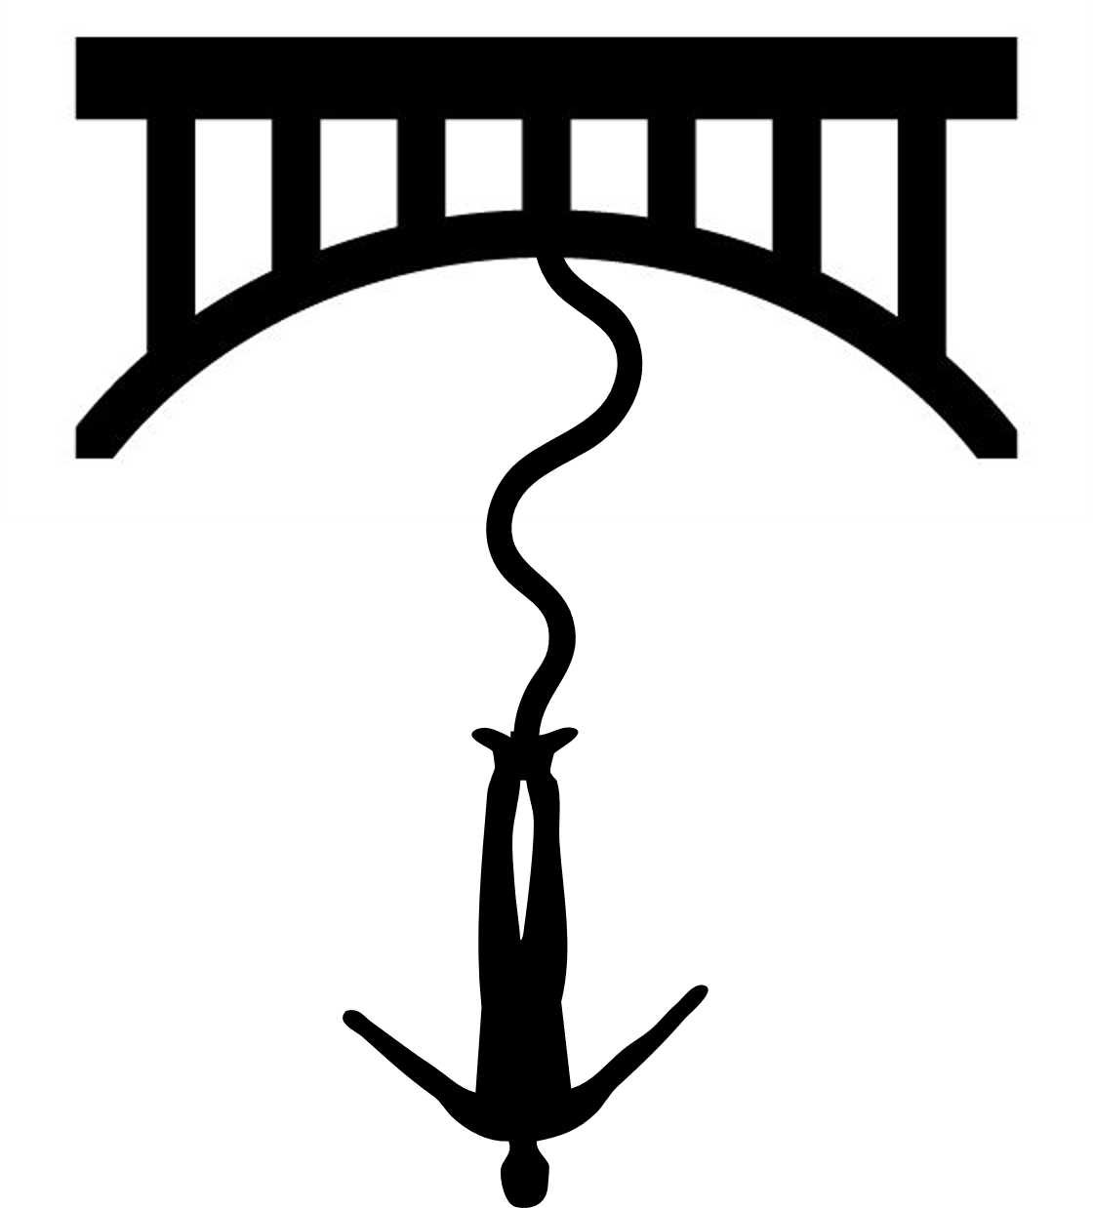 | Position #3  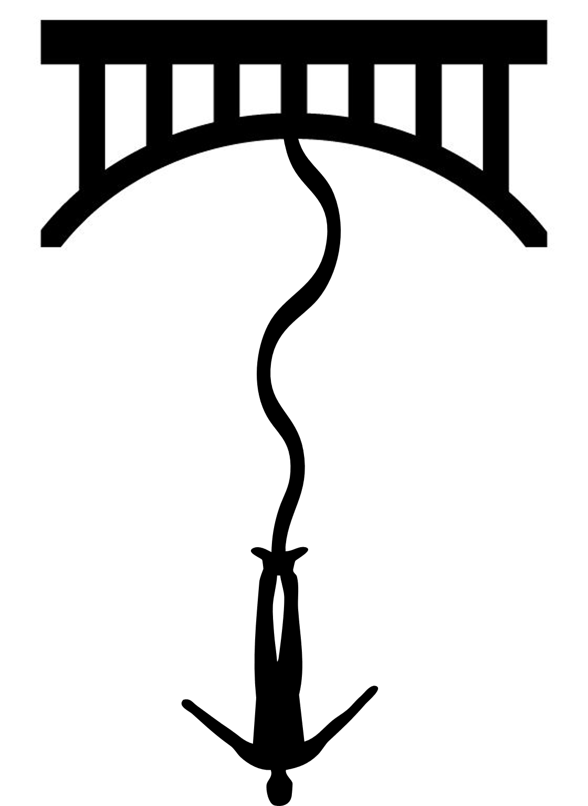
Note: Figures not drawn to scale. Not even close.
A thrill seeker safely attached to an elastic bungee cord is bobbing up and down as she dangles from a bridge above water. Her velocity, how quickly she is moving, periodically increases and decreases. While falling from her maximum height (position #1) to her minimum height (position #3), the thrill seeker is moving downward and is considered to have a negative velocity. The fastest portion of this fall is at the halfway point (position #2) when she is moving at $-11\frac{\text{m}}{\text{sec}}$. While rebounding back from her minimum height (position #3) to her maximum height (position #1), the thrill seeker is moving upward and is considered to have a positive velocity. Again, the fastest portion of this journey is at the halfway point (position #2) when she is moving at $11\frac{\text{m}}{\text{sec}}$. While at her maximum or minimum heights (positions #1 and #3), the thrill seeker is momentarily motionless, meaning that her velocity at these points is $0\frac{\text{m}}{\text{sec}}$. At time $t=0$, she is at her maximum height. It takes four seconds for her to reach her minimum height and another four seconds for her to return to her maximum height.
The sinusoidal function $h$ models the velocity of the thrill seeker, in meters per second, as a function of time $t$ in seconds. A positive velocity indicates the thrill seeker is moving up, and a negative velocity indicates the thrill seeker is moving down.
- The graph of $h$ and its dashed midline for two full cycles is shown. Five points, $F$, $G$, $J$, $K$, and $P$ are labeled on the graph. No scale is indicated, and no axes are presented.
Determine possible coordinates $\left(t, h\left(t\right)\right)$ for the five points: $F, G, J, K,$ and $P$.
- The function $h$ can be written in the form $h\left(t\right)=a\sin\left(b\left(t+c\right)\right)+d$. Find values of constants $a, b, c,$
and $d$.
- Refer to the graph of $h$ in part (A). The $t$-coordinate of $J$ is $t_{1}$ and the $t$-coordinate of $K$ is $t_{2}$.
- On the interval $\left(t_{1},t_{2}\right)$, which of the following is true about $h$?
  - $h$ is positive and increasing
  - $h$ is positive and decreasing
  - $h$ is negative and increasing
  - $h$ is negative and decreasing
- On the interval $\left(t_{1},t_{2}\right)$, describe the concavity of the graph of $h$ and determine whether the rate of change of $h$ is increasing or decreasing.

FRQ 3 Practice – Koala
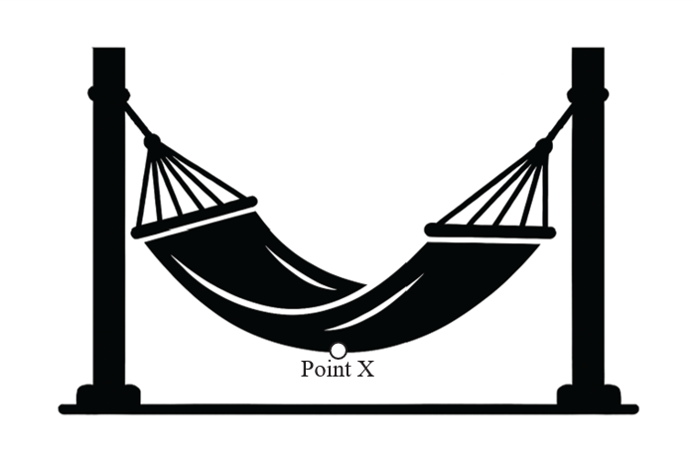
Note: Figure not drawn to scale.
The figure shows a hammock swinging in a constant breeze. Point $X$ is located in the middle of the hammock and, as the hammock swings, periodically moves toward and away from Roger. From its closest to its farthest, the distance between Point $X$ and Roger varies by as much as $3$ feet. At time $t=4$ seconds, Point $X$ is $10$ feet from Roger, the closest the point ever gets to him. It takes $0.4$ seconds for Point $X$ to then reach the location at which it is furthest from Roger.
The sinusoidal function $h$ models the distance between Point $X$ and Roger, in feet, as a function of time $t$ in seconds.
- The graph of $h$ and its dashed midline for two full cycles is shown. Five points, $F$, $G$, $J$, $K$, and $P$ are labeled on the graph. No scale is indicated, and no axes are presented.
Determine possible coordinates $\left(t, h\left(t\right)\right)$ for the five points: $F, G, J, K,$ and $P$.
- The function $h$ can be written in the form $h\left(t\right)=a\cos\left(b\left(t+c\right)\right)+d$. Find values of constants $a, b, c,$
and $d$.
- Refer to the graph of $h$ in part (A). The $t$-coordinate of $K$ is $t_{1}$ and the $t$-coordinate of $P$ is $t_{2}$.
- On the interval $\left(t_{1},t_{2}\right)$, which of the following is true about $h$?
  - $h$ is positive and increasing
  - $h$ is positive and decreasing
  - $h$ is negative and increasing
  - $h$ is negative and decreasing
- On the interval $\left(t_{1},t_{2}\right)$, describe the concavity of the graph of $h$ and determine whether the rate of change of $h$ is increasing or decreasing.

FRQ 3 Practice – Leporidae
The population of snowshoe hares in Canada can vary wildly. When the population of hares is high, the predator of the snowshoe hare (the lynx) thrives, driving the hare population down. When the hare population is down, their predator’s population suffers, which in turn allows the hare population to rebound. In a certain small town, studies have revealed that the population of snowshoe hares reaches a high of $7000$ hares and a low of $800$ hares. Further, the population cycles $4$ times every $48$ years. At time $t=2025$, the population of hares is $7000$.
The sinusoidal function $h$ models the snowshoe hare population as a function of time $t$ in years.
- The graph of $h$ and its dashed midline for two full cycles is shown. Five points, $F$, $G$, $J$, $K$, and $P$ are labeled on the graph. No scale is indicated, and no axes are presented.
Determine possible coordinates $\left(t, h\left(t\right)\right)$ for the five points: $F, G, J, K,$ and $P$.
- The function $h$ can be written in the form $h\left(t\right)=a\sin\left(b\left(t+c\right)\right)+d$. Find values of constants $a, b, c,$
and $d$.
- Refer to the graph of $h$ in part (A). The $t$-coordinate of $G$ is $t_{1}$ and the $t$-coordinate of $J$ is $t_{2}$.
- On the interval $\left(t_{1},t_{2}\right)$, which of the following is true about $h$?
  - $h$ is positive and increasing
  - $h$ is positive and decreasing
  - $h$ is negative and increasing
  - $h$ is negative and decreasing
- On the interval $\left(t_{1},t_{2}\right)$, describe the concavity of the graph of $h$ and determine whether the rate of change of $h$ is increasing or decreasing.

Solutions to FRQ 3 Practice – Antelope (Ferris Wheel)
- $F$ has coordinates $\left(-7,137\right)$
$G$ has coordinates $\left(0, 75\right)$
$J$ has coordinates $\left(7, 13\right)$
$K$ has coordinates $\left(14, 75\right)$
$P$ has coordinates $\left(21, 137\right)$
Note: $t$-coordinates will vary. A correct set of coordinates for one full cycle of $h$ as pictured is acceptable.
Part (A) is worth 2 points total:
1 point for $h\left(t\right)$-coordinates
1 point for $t$-coordinates
- $a=62$
$b=\frac{π}{14}$
$c=-21$
$d=75$
$h\left(t\right)=62\cos\left(\frac{π}{14}\left(t-21\right)\right)+75$
Note: Based on horizontal shifts and reflections, there are other correct forms for $h\left(t\right)$.
Part (B) is worth 2 points total:
1 point for vertical transformations: values of $a$ and $d$
1 point for horizontal transformations: values of $b$ and $c$

- Choice A
- The graph of $h$ is concave up on the interval $\left(t_{1}, t_{2}\right)$. The rate of change of $h$ is increasing on the interval $\left(t_{1}, t_{2}\right)$.
Part (C) is worth 2 points total:
1 point for part (i)
1 point for part (ii)

Solutions to FRQ 3 Practice – Baboon (Spit Roast)
- $F$ has coordinates $\left(-3.75,36\right)$
$G$ has coordinates $\left(-2.5, 42\right)$
$J$ has coordinates $\left(-1.25, 36\right)$
$K$ has coordinates $\left(0, 30\right)$
$P$ has coordinates $\left(1.25, 36\right)$
Note: $t$-coordinates will vary. A correct set of coordinates for one full cycle of $h$ as pictured is acceptable.
Part (A) is worth 2 points total:
1 point for $h\left(t\right)$-coordinates
1 point for $t$-coordinates
- $a=6$
$b=\frac{2π}{5}$
$c=2.5$
$d=36$
$h\left(t\right)=6\cos\left(\frac{2π}{5}\left(t+2.5\right)\right)+36$
Note: Based on horizontal shifts and reflections, there are other correct forms for $h\left(t\right)$.
Other correct forms for $h\left(t\right)$ are $h\left(t\right)=-6\cos\left(\frac{2π}{5}t\right)+36$ or $h\left(t\right)=6\cos\left(\frac{2π}{5}\left(t-2.5\right)\right)+36$
Part (B) is worth 2 points total:
1 point for vertical transformations: values of $a$ and $d$
1 point for horizontal transformations: values of $b$ and $c$

- Choice A
- The graph of $h$ is concave down on the interval $\left(t_{1}, t_{2}\right)$. The rate of change of $h$ is decreasing on the interval $\left(t_{1}, t_{2}\right)$.
Part (C) is worth 2 points total:
1 point for part (i)
1 point for part (ii)

Solutions to FRQ 3 Practice – Caterpillar (Paddle Wheel)
- $F$ has coordinates $\left(-2,5\right)$
$G$ has coordinates $\left(-1, -5\right)$
$J$ has coordinates $\left(0, -15\right)$
$K$ has coordinates $\left(1, -5\right)$
$P$ has coordinates $\left(2, 5\right)$
Note: $t$-coordinates will vary. A correct set of coordinates for one full cycle of $h$ as pictured is acceptable.
Part (A) is worth 2 points total:
1 point for $h\left(t\right)$-coordinates
1 point for $t$-coordinates
- $a=10$
$b=\frac{π}{2}$
$c=2$
$d=-5$
$h\left(t\right)=10\cos\left(\frac{π}{2}\left(t+2\right)\right)-5$
Note: Based on horizontal shifts and reflections, there are other correct forms for $h\left(t\right)$.
Other correct answers would be $h\left(t\right)=-10\cos\left(\frac{π}{2}t\right)-5$ or $h\left(t\right)=10\cos\left(\frac{π}{2}\left(t-2\right)\right)-5$.
Part (B) is worth 2 points total:
1 point for vertical transformations: values of $a$ and $d$
1 point for horizontal transformations: values of $b$ and $c$

- Choice D
- The graph of $h$ is concave up on the interval $\left(t_{1}, t_{2}\right)$. The rate of change of $h$ is increasing on the interval $\left(t_{1}, t_{2}\right)$.
Part (C) is worth 2 points total:
1 point for part (i)
1 point for part (ii)

Solutions to FRQ 3 Practice – Dingo (Daylight in Fairbanks)
- $F$ has coordinates $\left(0,22\right)$
$G$ has coordinates $\left(3, 13\right)$
$J$ has coordinates $\left(6, 4\right)$
$K$ has coordinates $\left(9, 13\right)$
$P$ has coordinates $\left(12, 22\right)$
Note: $t$-coordinates will vary. A correct set of coordinates for one full cycle of $h$ as pictured is acceptable.
Part (A) is worth 2 points total:
1 point for $h\left(t\right)$-coordinates
1 point for $t$-coordinates
- $a=9$
$b=\frac{π}{6}$
$c=-9$
$d=13$
$h\left(t\right)=9\sin\left(\frac{π}{6}\left(t-9\right)\right)+13$
Note: Based on horizontal shifts and reflections, there are other correct forms for $h\left(t\right)$.
Another correct answer is $h\left(t\right)=-9\sin\left(\frac{π}{6}\left(t-3\right)\right)+13$. A third correct answer is $9\sin\left(\frac{π}{6}\left(t+3\right)\right)+13$
Part (B) is worth 2 points total:
1 point for vertical transformations: values of $a$ and $d$
1 point for horizontal transformations: values of $b$ and $c$

- Choice B
- The graph of $h$ is concave up on the interval $\left(t_{1}, t_{2}\right)$. The rate of change of $h$ is increasing on the interval $\left(t_{1}, t_{2}\right)$.
Part (C) is worth 2 points total:
1 point for part (i)
1 point for part (ii)

Solutions to FRQ 3 Practice – Elephant (Washing Machine)
- $F$ has coordinates $\left(0,52.5\right)$
$G$ has coordinates $\left(\frac{1}{80}, 75\right)$
$J$ has coordinates $\left(\frac{1}{40}, 52.5\right)$
$K$ has coordinates $\left(\frac{3}{80}, 30\right)$
$P$ has coordinates $\left(\frac{1}{20}, 52.5\right)$
Note: $t$-coordinates will vary. A correct set of coordinates for one full cycle of $h$ as pictured is acceptable.
Part (A) is worth 2 points total:
1 point for $h\left(t\right)$-coordinates
1 point for $t$-coordinates
- $a=22.5$
$b=40π$
$c=0$
$d=52.5$
$h\left(t\right)=22.5\sin\left(40πt\right)+52.5$
Note: Based on horizontal shifts and reflections, there are other correct forms for $h\left(t\right)$.
Part (B) is worth 2 points total:
1 point for vertical transformations: values of $a$ and $d$
1 point for horizontal transformations: values of $b$ and $c$

- Choice B
- The graph of $h$ is concave down on the interval $\left(t_{1}, t_{2}\right)$. The rate of change of $h$ is decreasing on the interval $\left(t_{1}, t_{2}\right)$.
Part (C) is worth 2 points total:
1 point for part (i)
1 point for part (ii)

Solutions to FRQ 3 Practice – Flamingo (Helicopter Tail Rotor)
- $F$ has coordinates $\left(0,17\right)$
$G$ has coordinates $\left(3, 12\right)$
$J$ has coordinates $\left(6, 7\right)$
$K$ has coordinates $\left(9, 12\right)$
$P$ has coordinates $\left(12, 17\right)$
Note: $t$-coordinates will vary. A correct set of coordinates for one full cycle of $h$ as pictured is acceptable.
Part (A) is worth 2 points total:
1 point for $h\left(t\right)$-coordinates
1 point for $t$-coordinates
- $a=5$
$b=\frac{π}{6}$
$c=-9$
$d=12$
$h\left(t\right)=5\sin\left(\frac{π}{6}\left(t-9\right)\right)+12$
Note: Based on horizontal shifts and reflections, there are other correct forms for $h\left(t\right)$.
Another correct form of $h\left(t\right)$ is $h\left(t\right)=-5\sin\left(\frac{π}{6}\left(t-3\right)\right)+12$
Part (B) is worth 2 points total:
1 point for vertical transformations: values of $a$ and $d$
1 point for horizontal transformations: values of $b$ and $c$

- Choice B
- The graph of $h$ is concave down on the interval $\left(t_{1}, t_{2}\right)$. The rate of change of $h$ is decreasing on the interval $\left(t_{1}, t_{2}\right)$.
Part (C) is worth 2 points total:
1 point for part (i)
1 point for part (ii)

Solutions to FRQ 3 Practice – Giraffe (Human Running Head Height)
- $F$ has coordinates $\left(-\frac{1}{6},178\right)$
$G$ has coordinates $\left(-\frac{1}{12}, 174\right)$
$J$ has coordinates $\left(0, 170\right)$
$K$ has coordinates $\left(\frac{1}{12}, 174\right)$
$P$ has coordinates $\left(\frac{1}{6}, 178\right)$
Note: $t$-coordinates will vary. A correct set of coordinates for one full cycle of $h$ as pictured is acceptable.
Part (A) is worth 2 points total:
1 point for $h\left(t\right)$-coordinates
1 point for $t$-coordinates
- $a=4$
$b=6π$
$c=-\frac{1}{12}$
$d=174$
$h\left(t\right)=4\sin\left(6π\left(t-\frac{1}{12}\right)\right)+174$
Note: Based on horizontal shifts and reflections, there are other correct forms for $h\left(t\right)$.
Part (B) is worth 2 points total:
1 point for vertical transformations: values of $a$ and $d$
1 point for horizontal transformations: values of $b$ and $c$

- Choice A
- The graph of $h$ is concave down on the interval $\left(t_{1}, t_{2}\right)$. The rate of change of $h$ is decreasing on the interval $\left(t_{1}, t_{2}\right)$.
Part (C) is worth 2 points total:
1 point for part (i)
1 point for part (ii)

Solutions to FRQ 3 Practice – Hippopotamus (Volume of Blood in Heart)
- $F$ has coordinates $\left(-\frac{1}{200},130\right)$
$G$ has coordinates $\left(0, 180\right)$
$J$ has coordinates $\left(\frac{1}{200}, 130\right)$
$K$ has coordinates $\left(\frac{2}{200}, 80\right)$
$P$ has coordinates $\left(\frac{3}{200}, 130\right)$
Note: $t$-coordinates will vary. A correct set of coordinates for one full cycle of $h$ as pictured is acceptable.
Part (A) is worth 2 points total:
1 point for $h\left(t\right)$-coordinates
1 point for $t$-coordinates
- $a=50$
$b=100π$
$c=0$
$d=130$
$h\left(t\right)=50\cos\left(100π\left(t+0\right)\right)+130$
Note: Based on horizontal shifts and reflections, there are other correct forms for $h\left(t\right)$.
Part (B) is worth 2 points total:
1 point for vertical transformations: values of $a$ and $d$
1 point for horizontal transformations: values of $b$ and $c$

- Choice A
- The graph of $h$ is concave up on the interval $\left(t_{1}, t_{2}\right)$. The rate of change of $h$ is increasing on the interval $\left(t_{1}, t_{2}\right)$.
Part (C) is worth 2 points total:
1 point for part (i)
1 point for part (ii)

Solutions to FRQ 3 Practice – Iguana (Wind Turbine)
- $F$ has coordinates $\left(-0.5, 155\right)$
$G$ has coordinates $\left(1, 100\right)$
$J$ has coordinates $\left(2.5, 45\right)$
$K$ has coordinates $\left(4, 100\right)$
$P$ has coordinates $\left(5.5, 155\right)$
Note: $t$-coordinates will vary. A correct set of coordinates for one full cycle of $h$ as pictured is acceptable.
Part (A) is worth 2 points total:
1 point for $h\left(t\right)$-coordinates
1 point for $t$-coordinates
- $a=55$
$b=\frac{2π}{6}=\frac{π}{3}$
$c=-5.5$
$d=100$
$h\left(t\right)=55\cos\left(\frac{π}{3}\left(t-5.5\right)\right)+100$
Note: Based on horizontal shifts and reflections, there are other correct forms for $h\left(t\right)$.
Part (B) is worth 2 points total:
1 point for vertical transformations: values of $a$ and $d$
1 point for horizontal transformations: values of $b$ and $c$

- Choice B
- The graph of $h$ is concave up on the interval $\left(t_{1}, t_{2}\right)$. The rate of change of $h$ is increasing on the interval $\left(t_{1}, t_{2}\right)$.
Part (C) is worth 2 points total:
1 point for part (i)
1 point for part (ii)

Solutions to FRQ 3 Practice – Jaguar (Bungee Jumping)
- $F$ has coordinates $\left(-2, 11\right)$
$G$ has coordinates $\left(0, 0\right)$
$J$ has coordinates $\left(2, -11\right)$
$K$ has coordinates $\left(4, 0\right)$
$P$ has coordinates $\left(6, 11\right)$
Note: $t$-coordinates will vary. A correct set of coordinates for one full cycle of $h$ as pictured is acceptable.
Part (A) is worth 2 points total:
1 point for $h\left(t\right)$-coordinates
1 point for $t$-coordinates
- $a=11$
$b=\frac{2π}{8}=\frac{π}{4}$
$c=-4$
$d=0$
$h\left(t\right)=11\sin\left(\frac{π}{4}\left(t-4\right)\right)+0$
Note: Based on horizontal shifts and reflections, there are other correct forms for $h\left(t\right)$.
Part (B) is worth 2 points total:
1 point for vertical transformations: values of $a$ and $d$
1 point for horizontal transformations: values of $b$ and $c$

- Choice C
- The graph of $h$ is concave up on the interval $\left(t_{1}, t_{2}\right)$. The rate of change of $h$ is increasing on the interval $\left(t_{1}, t_{2}\right)$.
Part (C) is worth 2 points total:
1 point for part (i)
1 point for part (ii)

Solutions to FRQ 3 Practice – Koala (Hammock)
- $F$ has coordinates $\left(3.6, 13\right)$
$G$ has coordinates $\left(3.8, 11.5\right)$
$J$ has coordinates $\left(4, 10\right)$
$K$ has coordinates $\left(4.2, 11.5\right)$
$P$ has coordinates $\left(4.4, 13\right)$
Note: $t$-coordinates will vary. A correct set of coordinates for one full cycle of $h$ as pictured is acceptable.
Part (A) is worth 2 points total:
1 point for $h\left(t\right)$-coordinates
1 point for $t$-coordinates
- $a=1.5$
$b=\frac{2π}{0.8}=\frac{5π}{2}$
$c=-3.6$
$d=11.5$
$h\left(t\right)=1.5\cos\left(\frac{5π}{2}\left(t-3.6\right)\right)+11.5$
Note: Based on horizontal shifts and reflections, there are other correct forms for $h\left(t\right)$.
Part (B) is worth 2 points total:
1 point for vertical transformations: values of $a$ and $d$
1 point for horizontal transformations: values of $b$ and $c$

- Choice A
- The graph of $h$ is concave up on the interval $\left(t_{1}, t_{2}\right)$. The rate of change of $h$ is increasing on the interval $\left(t_{1}, t_{2}\right)$.
Part (C) is worth 2 points total:
1 point for part (i)
1 point for part (ii)

Solutions to FRQ 3 Practice – Leporidae (Hares)
- $F$ has coordinates $\left(2025, 7000\right)$
$G$ has coordinates $\left(2028, 3900\right)$
$J$ has coordinates $\left(2031, 800\right)$
$K$ has coordinates $\left(2034, 3900\right)$
$P$ has coordinates $\left(2037, 7000\right)$
Note: $t$-coordinates will vary. A correct set of coordinates for one full cycle of $h$ as pictured is acceptable.
Part (A) is worth 2 points total:
1 point for $h\left(t\right)$-coordinates
1 point for $t$-coordinates
- $a=3100$
$b=\frac{2π}{12}=\frac{π}{6}$
$c=-2034$
$d=3900$
$h\left(t\right)=3100\sin\left(\frac{π}{6}\left(t-2034\right)\right)+3900$
Note: Based on horizontal shifts and reflections, there are other correct forms for $h\left(t\right)$.
Part (B) is worth 2 points total:
1 point for vertical transformations: values of $a$ and $d$
1 point for horizontal transformations: values of $b$ and $c$

- Choice B
- The graph of $h$ is concave up on the interval $\left(t_{1}, t_{2}\right)$. The rate of change of $h$ is increasing on the interval $\left(t_{1}, t_{2}\right)$.
Part (C) is worth 2 points total:
1 point for part (i)
1 point for part (ii)

